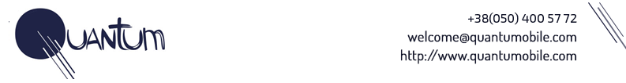

**Test task**

In internship time you will solve a couple of different tasks in the field of computer vision.

This task will give you a basic understanding of techniques and frameworks which we use on a daily basis to solve similar problems.

**Dataset:**

<https://www.kaggle.com/c/data-science-bowl-2018/data>

**Goal:**

Build a **semantic** segmentation model with UNet architecture using Keras.

**Please note, that test task is not instance segmentation!**

**Results:**

As results you must provide a link to your GitHub repo that will include:

1. README.md with a description of techniques that you have used to solve the task and instructions for running training and prediction.
2. Requirements.txt
3. Train.py - the script that will run training.
4. Predict_masks.py - a script that will run inference on test data.
5. Jupyter notebook with exploratory data analysis.
6. Any other scripts with datasets, models, etc…

**Main requirements**

1. Completely working code.
2. It must be easy to set up the environment and run it.
3. Dice Score score at each image <https://en.wikipedia.org/wiki/S%C3%B8rensen%E2%80%93Dice_coefficient> - 0.4

**Useful links**

1. Kaggle competition kernels will help you to understand data and find some insights.
2. <https://adeshpande3.github.io/adeshpande3.github.io/A-Beginner%27s-Guide-To-Understanding-Convolutional-Neural-Networks/>
3. UNET paper <https://arxiv.org/abs/1505.04597>
4. Semantic vs instance segmentation <https://www.quora.com/What-are-the-differences-between-semantic-segmentation-instance-detection-and-object-proposal>